Hunter and Hunted Order Form

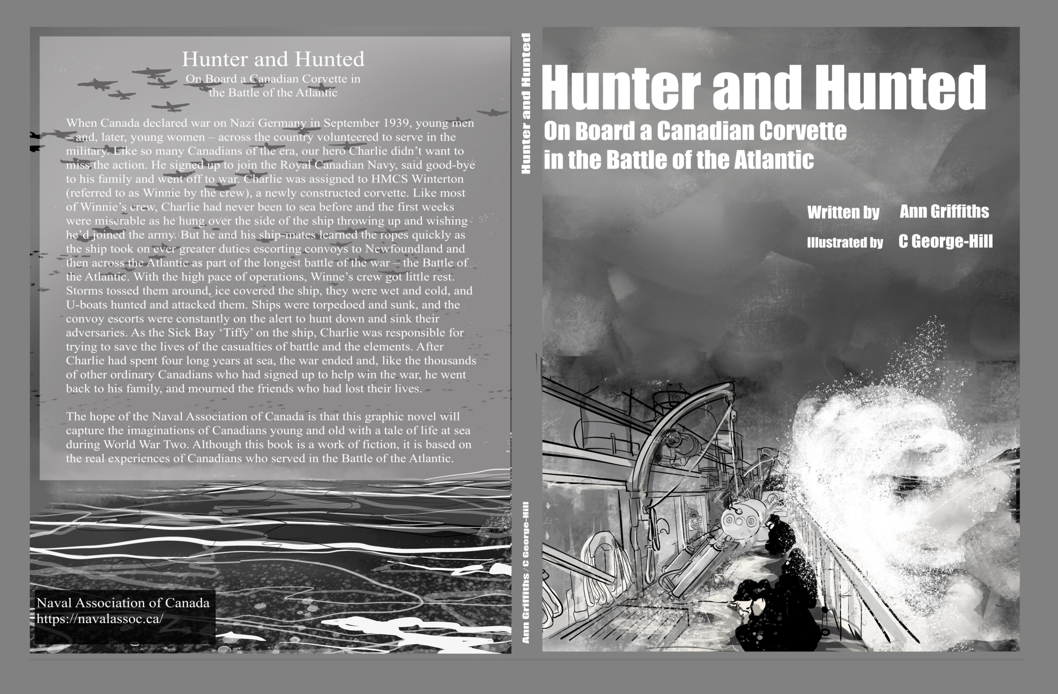

Quantity | Product | Price | Total
 | Hunter and Hunted | $30
 | S+H $10.00 per book for orders in Canada.  For orders outside Canada, postage price will differ. Contact NAC for information on postage rates outside Canada or for local pick up in Ottawa. | $10 (per book)
 | Total Order

Please email NACcoordinator@navalassoc.ca for more info and to make a purchase.

Name: ......................................................................................................................................
Mailing Address: .....................................................................................................................
City: ................................................... Province: .................................. Postal Code: ...................
Daytime Phone: ............................... Email: ..........................................................

Payment: Please contact NACcoordinator@navalassoc.ca
Online order securely by credit card is available Naval Association of Canada - Products
Etransfer to executivedirector@navalassoc.ca is available
You can send a cheque if needed. Please email NACcoordinator@navalassoc.ca for info.

