Naval Association of Canada
Children’s Book Order From

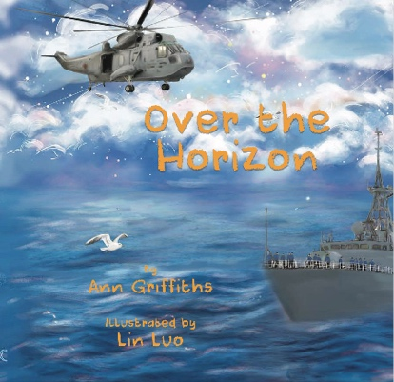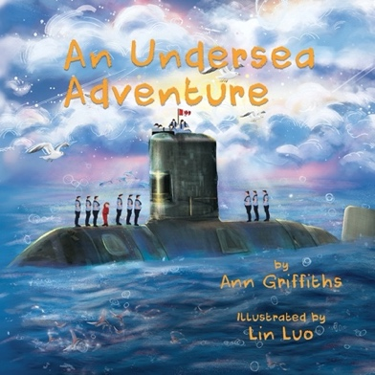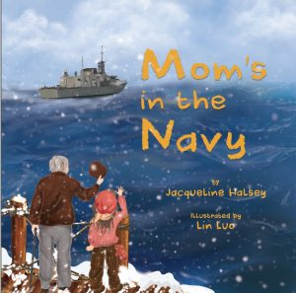

If ordering by email send the form or your info to the NACcoordinator@navalassoc.ca

Quantity | Product | Price | Total
 | Mom’s in the Navy (English or French) | $15
 | An Undersea Adventure (English or French) | $15
 | Over the Horizon (English or French) | $15
 | S+H $70.00 per book for orders in Canada.  For orders outside Canada, postage price will differ. Contact NAC for information on postage rates outside Canada or for local pick up in Ottawa.  SPECIAL OFFER  Order all 3 books for $50 including S+H in Canada | $7 (per book)  or see special offer
 | Total Order

NOTE: All three books are available in English or en français

Please email NACcoordinator@navalassoc.ca for more info and to make a purchase.

Name: ......................................................................................................................................
Mailing Address: .....................................................................................................................
City: ................................................... Province: .................................. Postal Code: ...................
Daytime Phone: ............................... Email: ..........................................................

Payment: Please contact NACcoordinator@navalassoc.ca
Online order securely by credit card is available Naval Association of Canada - Products
Etransfer to executivedirector@navalassoc.ca is available
You can send a cheque if needed. Please email NACcoordinator@navalassoc.ca for info.

